**Exhaustive Analysis of Indian Agriculture Sector Using Power BI**

**Operations Performed on PowerBI:**

**ETL: (Extract, Transform, Load)**

**Extract:** Upload data from Any sources in the format of CSV, Excel, Json, PDF’s, XML, Parquet, Databases, Vertica, GitHub (Beta), etc.,

**Transform:** Used to do Data Preprocessing, Data Cleaning by removing Noisy data like null values, Errors etc.,

**Load:** it is the final process before analysing the data to upload the data from **Power Query Editor** to **PowerBI Desktop**

**Views that are in PowerBI:**

**Report View:** this view is used to visualize the data into different Visualizations like Pie Chart, Bar Chart, R Script Visual, Key Influencers, Azure Map, Table, Matrix etc.,

**Table View:** This view is used to show the data that is transformed and loaded into the PowerBI Desktop.

**Model View:** This View is used to show the relationship between different datasets.

**Steps:**

Step 1: Open PowerBI Desktop and open a blank project.

Step 2: Then Click on Get Data and then select the data format that we want to upload the data.

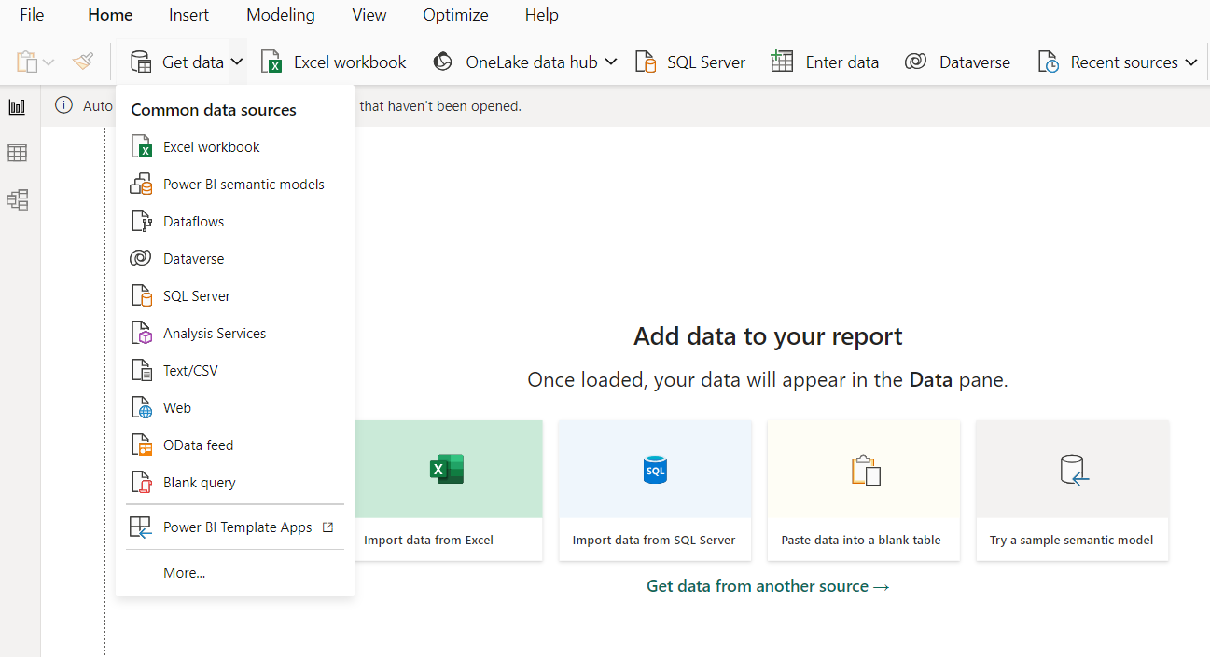

Step 3: Then if we want to delete any unnecessary data in either rows or columns then we can delete that data this all can be performed in transformation phase.

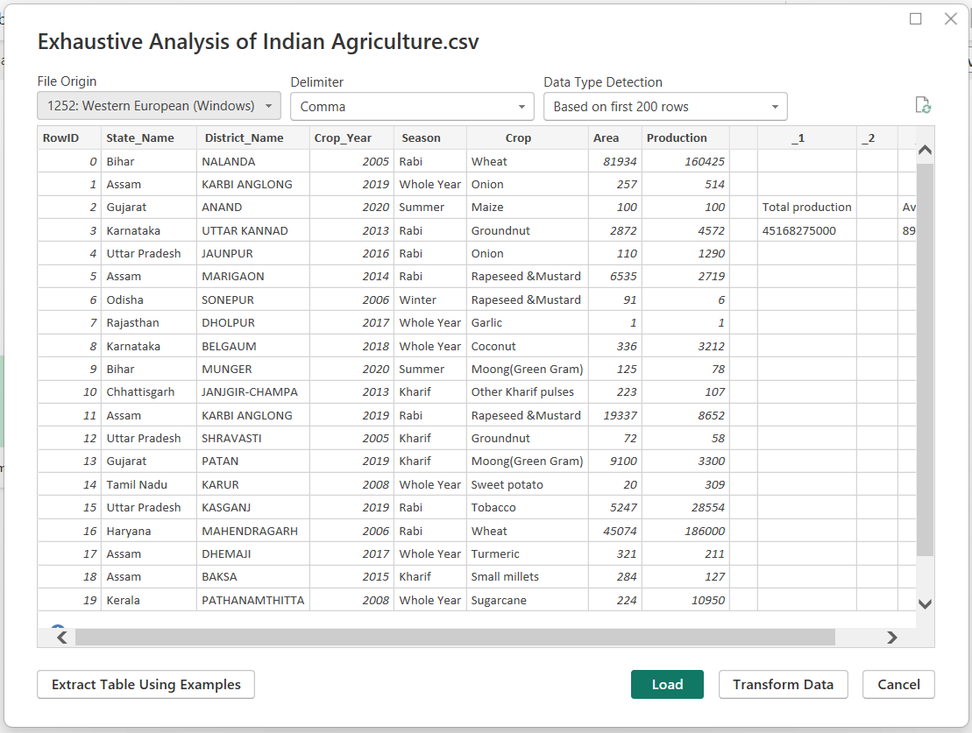Step 4: Then click on load, after all the transformations had done to get cleaned data.

Step 5: Then we will be getting table view like this

